**Project Report Template**

**1 INTRODUCTION**

**Overview**

CRM(Customer Relationship Management) is a category of Software Solution That Spans different customer management systems-such as Sales, Service and Marketing and allows them to work together. It streamlines your business processes and connects customer data to help you build relationships ,Initiatives to save time and effort, increases productivity, and improves customer engagement.

**Purposes**

CRM Software helps you on focus on your organisation’s relationships with individual people – including customers , service users, colleagues or suppliers –throughout your lifecycle with them , including finding new customers, winning their business and additional services throughout the relationship .With CRM solutions, the sales and marketing team can track and follow a customer interaction journey with your business.

**2 Problem definition & Design Thinking**

**Empathy Map**

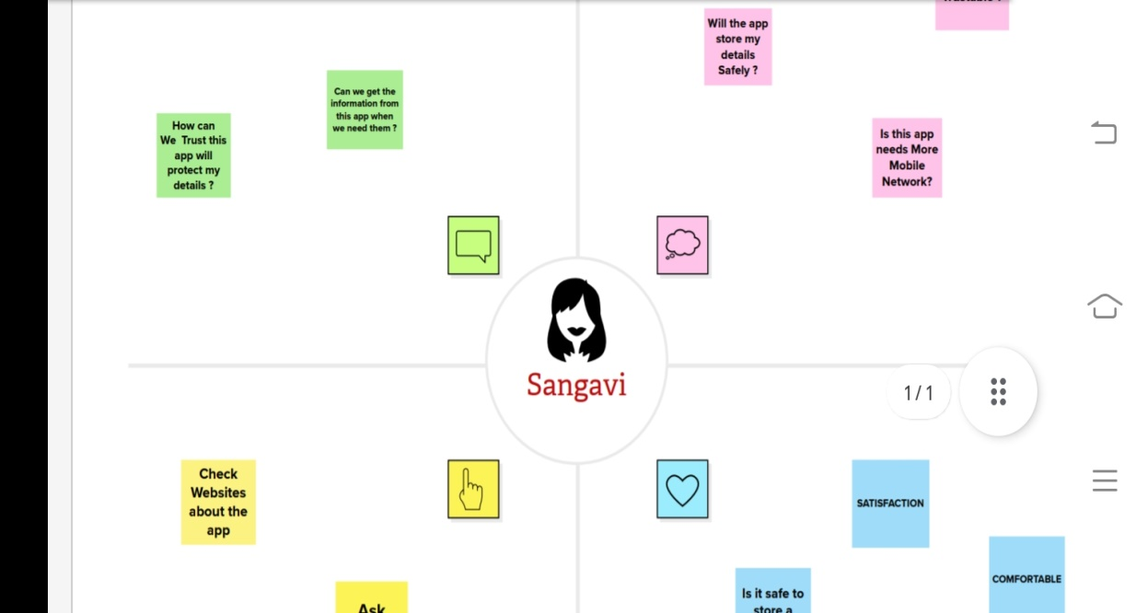

**Ideation & Brainstorming Map**

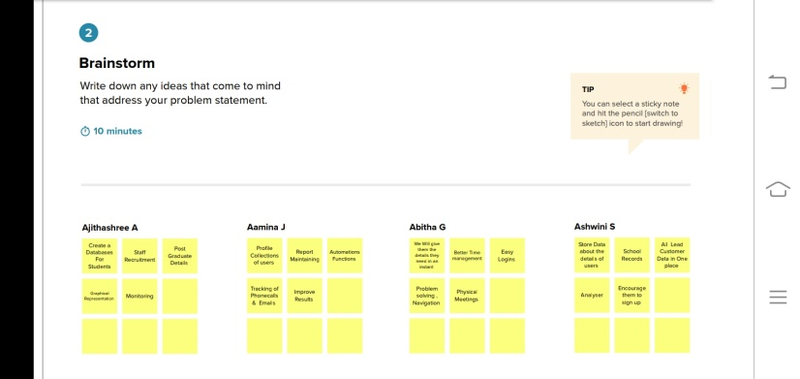

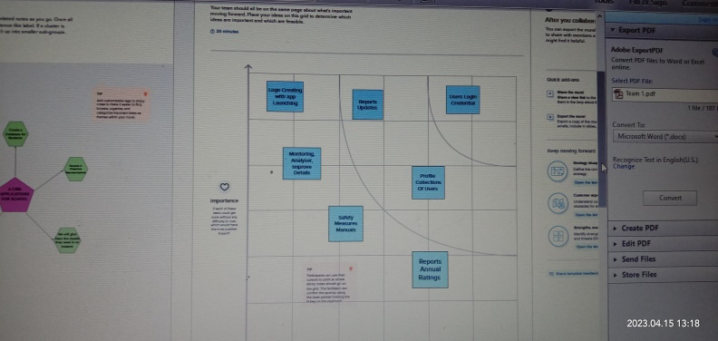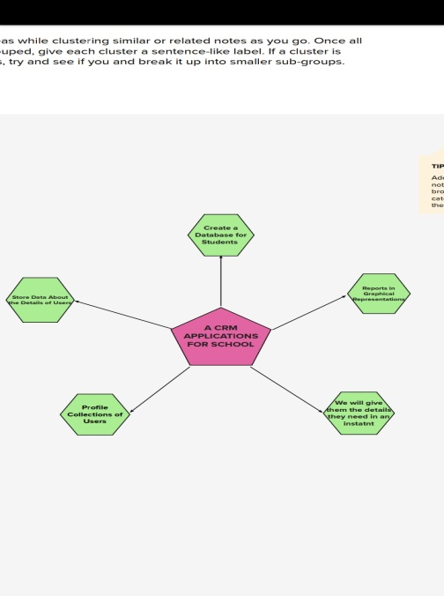

**3 RESULT**

**Data Model**

|  |  |
| --- | --- |
| **Object Name** | **Fields in Object** |
| Object – 1 | Field Label : Phone Number  Data Type : Phone  Field Label : School  Data Type : Master- Detail Relationship |
| Object – 2 | Field Label : Results  Data Type : Picklist  Field Label: Class  Data Type : Number |

**Activity & Screenshot**

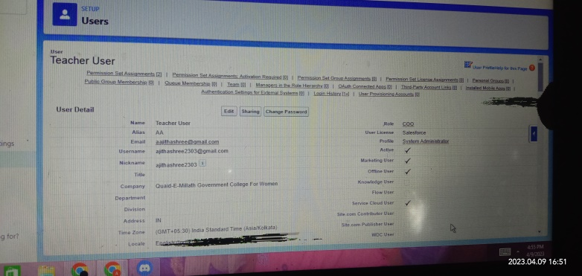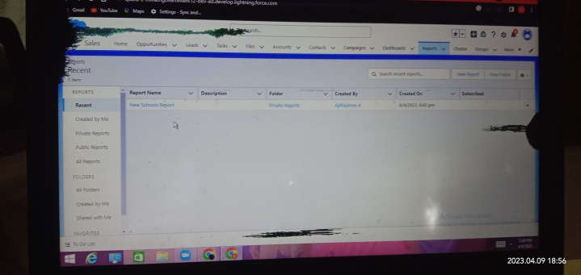

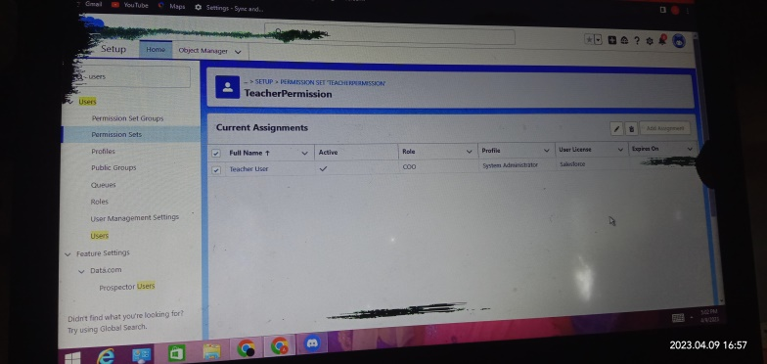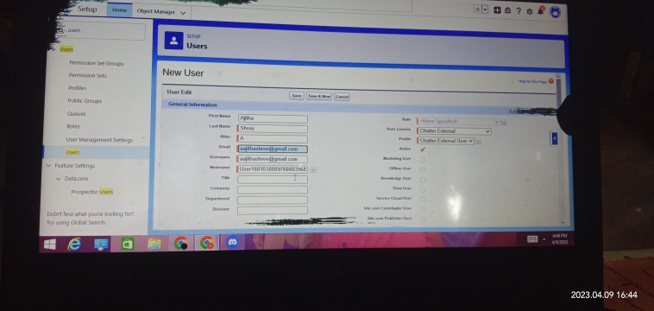

**4 Trailhead Profile Public URL**

**Team Leader -** [**https://trailblazer.me/id/ajita22**](https://trailblazer.me/id/ajita22)

**Team Member 1 –** [**https://trailblazer.me/id/aamij**](https://trailblazer.me/id/aamij)

**Team Member 2 –** [**https://trailblazer.me/id/aabitha4**](https://trailblazer.me/id/aabitha4)

**Team Member 3 –** [**https://trailblazer.me/id/aaswini12**](https://trailblazer.me/id/aaswini12)

**Project Report Template**

**5 Advantages & Disadvantages**

|  |  |
| --- | --- |
| **Advantages** | **Disadvantages** |
| * It allows for more effective Sales & marketing. * It can Spend up the sales conversion processes. * It Increases Staff Productivity, lower time costs & boosts morale. * It enables widely dispersed teams to work closely. * It can Improve customer loyalty through exceptional experience. | * Staff over- reliance on CRM may diminish customer loyalty through a bad experience. * Security concerns associated with centralized data. * The excess initial time and productivity cost of implementation. * It requires a process driven sales organization. * It may not suit every Business. |

**6 Applications**

* Tracking Customers.
* Collecting Data for Marketing.
* Improving interactions & Communication.
* Streamlining internal Sales Processes.
* Planning Your Operations.

**7 Conclusion**

Customer Relationship Management enables a company to align its Strategy with the needs of the customer in order to best meet those needs & thus ensure long term Customer loyalty .

**8 Future Scope**

These Days, Numerous small and medium sized enterprises are arising across the world. Unlike large organizations , they are reluctant to implement CRM software. The companies didn’t have the expertise to manage the CRM software inhouse .These Technicians used to charge a lump sum amount in exchange do their services . So don’t be late and perform the necessities for implementing the CRM software in your business.